National Oil & Gas Workgroup Repository
Activity data for O&G drilling and production, HC containing geologic formations; Emission Factors by facility and equipment type; Emissions inventories and available tool for inquiry and access; Regulatory Programs; NEPA planning process; State of the science literature articles and reports.

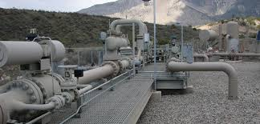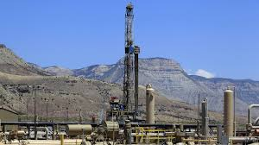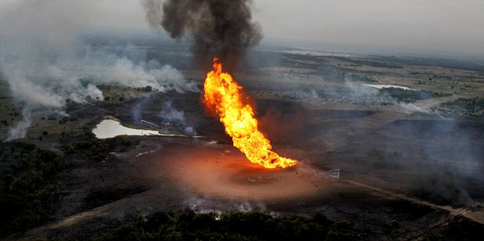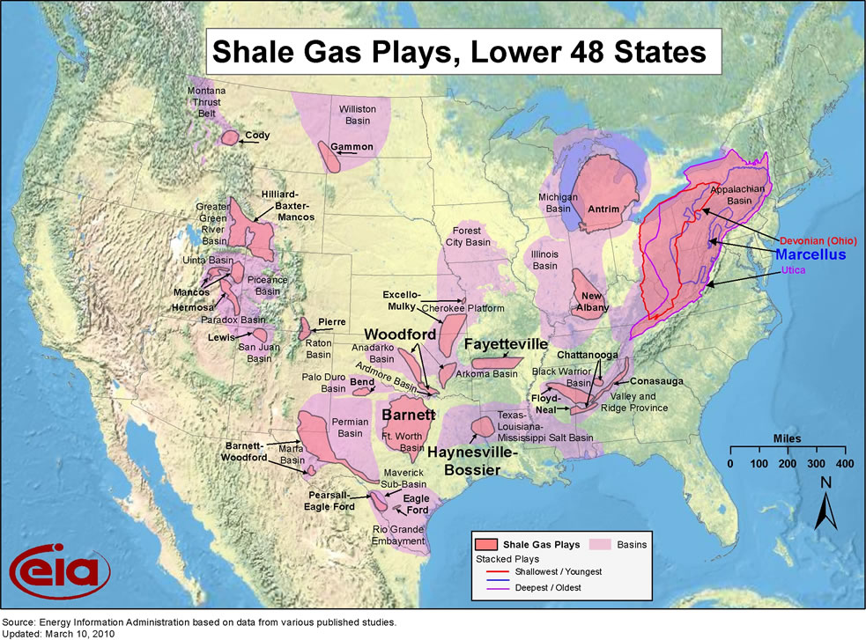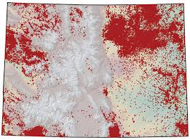

Background information from the WRAP web

A.L Mitchel, et al., ES&T 2015, Environmental Protection Agency figures for emissions from [O&G Transmission and Storage] sectors may be missing a large number of methane leaks.
A.R. Brandt et al., Science, 2014, Methane emissions from U.S. and Canadian natural gas systems appear larger than official estimates
K. McKain et al., PNAS 2014, Methane emissions from natural gas infrastructure in Boston MA are larger than national and state inventories.

Meetings
State of the Science

Commercial Activity Reports
- ISH rig activity
- HPDI production reports
State Databases
- Colorado – O&G Facilities GIS - web
- North Dakota - Department of Mineral Resources, Oil and Gas Division - web
- Utah – AGRC web – interactive GIS map web
U.S. EIA
- Natural gas exploration and reserves
- Natural gas respondent surveys
Other resources
- Intermountain Oil and Gas BMP Project – GIS systems for O&G web – includes links to interactive GIS based mapping tools from BLM, USGS, Colorado O&G Conservation Commission, Utah, Montana, Wyoming, New Mexico

Activity

Background

EPA tools
- Clearinghouse for Inventories and Emissions Factors (CHIEF) web – key emission factors databases and tools are listed below
- Software and tools web
  - SPECIATE v4.4
  - AP42 – compilation of air pollutant emissions factors by source category
- O&G Area Source Emissions Estimation tool – link to ppt on wrap site, is there a link for the tool?
BLM emissions tool kits (Check with Aumann)

Emissions Factors

WAQDW (we should differentiate 3State modeling platforms from EPA platforms)
- WAQDW Studies - web
- Basin level inventories (are there disaggregated inventories at the basin level in 3State?)
EPA
- Clearinghouse for Inventories and Emissions Factors (CHIEF) web – key inventories are listed in the sub bullets
  - Emissions Inventories web – includes 2011 NEI and 2014 NEI documentation.
  - Emissions Modeling Clearinghouse web – includes 2011NEIv2 based platform (2011v6.2), Ozone NAAQS Emissions Modeling Platform (2011v6.1) for 2011, 2018 & 2025, etc.
- EIS Gateway – web – Emissions Inventory Gateway (requires user ID and password)
- US Environmental Protection Agency, flight (Facility Level Information on GreenHouse gasses Tool) www.ghgdata.epa.gov/ghgp - 2013 Greenhouse Gas Emissions from Large Facilities.
Emissions Reconciliations
- Top down vs. bottom up studies link (filters articles page on this subject)
Emissions Inventories

National
- US Environmental Protection Agency (2014) Greenhouse Gas Reporting Program, Subpart W, Petroleum and Natural Gas Systems Subpart W Rulemaking Resources. web
State
- Colorado Oil & Gas Conservation Commission web – includes complaints data base, etc.
Tribal
- Tribal Minor New Source Review Rule - web
Other resources
- Intermountain Oil and Gas BMP Project – law and policy web
Regulatory Programs

- Western Air Quality Data Warehouse - web
NEPA Planning

[footer]
DISCLAMER

Meetings

State of the Science: Articles & Reports
US Environmental Protection Agency, Office of The Inspector General (2014), Improvements Needed in EPA Efforts to Address Methane Emissions From Natural Gas Distribution Pipelines, Report No. 14-P-0324. www.epa.gov/oig/reports/2014/20140729-14-P-0325.pdf
The White House (2014) Climate Action Plan: Strategy to Reduce Methane Emissions. www.whitehouse.gov/sites/default/files/strategy_to_reduce_methane_emissions_2014-03-28_final.pdf

Mitchell, A. L., Tkacik, D. S., Roscioli, J. R., Herndon, S. C., Yacovitch, T. I., Martinez, D. M., . . . Robinson, A. L. (2015). Measurements of Methane Emissions from Natural Gas Gathering Facilities and Processing Plants: Measurement Results. Environmental Science & Technology. doi: 10.1021/es5052809
McKain, K., Down, A., Raciti, S. M., Budney, J., Hutyra, L. R., Floerchinger, C., . . . Wofsy, S. C. (2015). Methane emissions from natural gas infrastructure and use in the urban region of Boston, Massachusetts. Proceedings of the National Academy of Sciences. doi: 10.1073/pnas.1416261112
Correction for Allen et al., Measurements of methane emissions at natural gas production sites in the United States. (2013). Proceedings of the National Academy of Sciences, 110(44), 18023. doi: 10.1073/pnas.1318658110
Allen, D. T., Torres, V. M., Thomas, J., Sullivan, D. W., Harrison, M., Hendler, A., . . . Seinfeld, J. H. (2013). Measurements of methane emissions at natural gas production sites in the United States. Proceedings of the National Academy of Sciences, 110(44), 17768-17773. doi: 10.1073/pnas.1304880110
Caulton, D. R., Shepson, P. B., Santoro, R. L., Sparks, J. P., Howarth, R. W., Ingraffea, A. R., . . . Miller, B. R. (2014). Toward a better understanding and quantification of methane emissions from shale gas development. Proceedings of the National Academy of Sciences, 111(17), 6237-6242. doi: 10.1073/pnas.1316546111
Chang, R. Y.-W., Miller, C. E., Dinardo, S. J., Karion, A., Sweeney, C., Daube, B. C., . . . Wofsy, S. C. (2014). Methane emissions from Alaska in 2012 from CARVE airborne observations. Proceedings of the National Academy of Sciences, 111(47), 16694-16699. doi: 10.1073/pnas.1412953111
Heath, G. A., O’Donoughue, P., Arent, D. J., & Bazilian, M. (2014). Harmonization of initial estimates of shale gas life cycle greenhouse gas emissions for electric power generation. Proceedings of the National Academy of Sciences, 111(31), E3167-E3176. doi: 10.1073/pnas.1309334111
Hristov, A. N., Johnson, K. A., & Kebreab, E. (2014). Livestock methane emissions in the United States. Proceedings of the National Academy of Sciences, 111(14), E1320. doi: 10.1073/pnas.1401046111
Jackson, R. B. (2014). The integrity of oil and gas wells. Proceedings of the National Academy of Sciences, 111(30), 10902-10903. doi: 10.1073/pnas.1410786111
Johnson, D., Covington, A., & Clark, N. (2014). Environmental and Economic Assessment of Leak and Loss Audits at Natural Gas Compressor and Storage Facilities. Energy Technology, 2(12), 1027-1032. doi: 10.1002/ente.201402086
Johnson, M. S., Yates, E. L., Iraci, L. T., Loewenstein, M., Tadić, J. M., Wecht, K. J., . . . Fischer, M. L. (2014). Analyzing source apportioned methane in northern California during Discover-AQ-CA using airborne measurements and model simulations. Atmospheric Environment, 99(0), 248-256. doi: http://dx.doi.org/10.1016/j.atmosenv.2014.09.068

